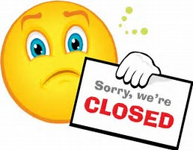
10th October 2017 Closed-12pm-17.30pm
15th November 2017 Closed-12pm and 16.30pm
21st February 2018 Closed-12pm-17.30pm
21st March 2018 Closed-12pm and 16.30pm

In order to improve the service we provide for our patients on the above dates we will be closed for practice training.
There is still an urgent service available should you need to access healthcare during this time by calling NHS111.
We apologize for an inconvenience caused but hope you will understand this helps us provide the patients with the most up to date health services.

