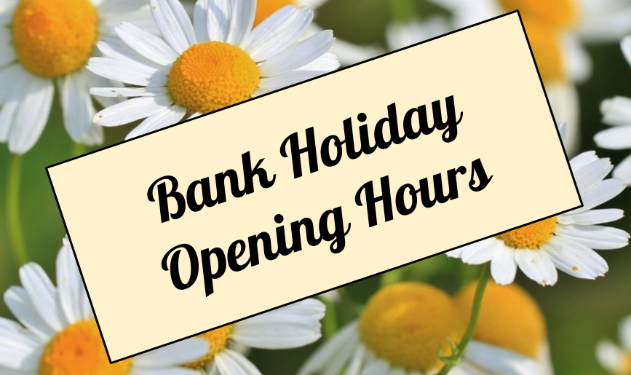
Friday 4th May Normal Hours 8.30am-6.30pm
Sat 5th May Closed
Sun 6th May Closed
Monday 7th May Bank Holiday Closed
Tuesday 8th May Normal Hours 8.30am-6.30pm

