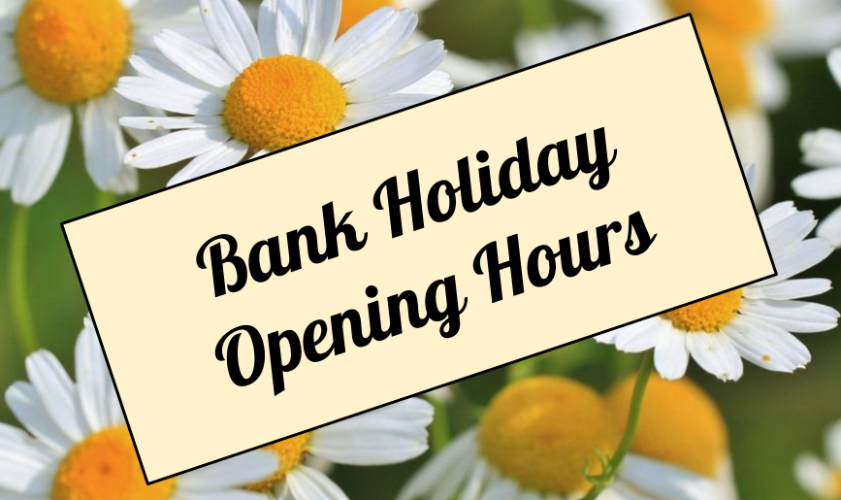

Friday 25th May 8.30-6.30pm
Sat 26th May Closed
Sun 27th May Closed
Mon 28th May Bank Holiday Closed
Tues 29th May 8.30-6.30pm

