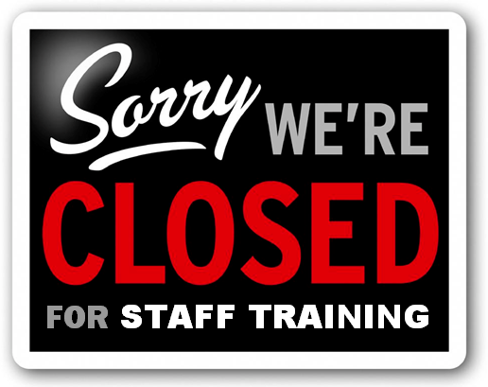
In order to improve the service we provide for you - our patients - We will be closed from 12:00pm until 5.30pm on the 16th May for training.

There is still an urgent service available should you need to access healthcare during the afternoon and if you do need NHS help during this time please call the following number: 07547 656200.
We have taken extra steps to make sure we can see as many patients as possible during the morning on the 16th May

We apologise for any inconvenience caused but hope that you can understand the importance of this activity, which will ensure we are able to provide you with the most up-to-date and best possible health services.

Please remember A&E is only for patients requiring accident and emergency care, for serious and life threatening conditions. Please use the number above if you have concerns about your health on this afternoon and only use A&E in an emergency.

